**Vision and Imaging Science Research**

**Minjae Kang: Face recognition**

**What is Face Recognition?**

Face recognition (also called facial recognition) is a method of identifying an individual by comparing digital image data with the stored record for that person. This is one of the biometric(https://en.wikipedia.org/wiki/Biometrics) identification systems. Other known forms of this type of work include [fingerprint matching](https://gcn.com/articles/2017/01/26/iarpa-fingerprints.aspx) and [voice recognition](https://www.biometricupdate.com/201703/pindrop-voice-authentication-to-be-integrated-with-amazon-connect).

Facial recognition systems are commonly used for security purposes but are increasingly being used in a variety of other applications.

**https://www.youtube.com/watch?v=wve5JWX7yoc**

**How does it work?**

Facial recognition analyses the characteristics of a person's face images input through a digital video camera. It measures the overall facial structure, including distances between eyes, nose, mouth, and jaw edges. These measurements are recorded in a database and used as a comparison when a user stands before the camera.

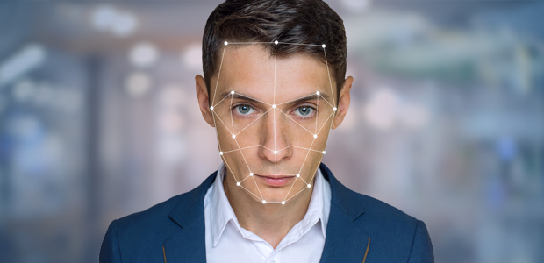

**How is facial recognition technology being applied and used in society?**

Facial recognition systems are commonly used for security purposes, but are increasingly being used in a variety of other applications. Some [mobile payment](http://searchmobilecomputing.techtarget.com/definition/m-payment) systems use facial recognition to securely authenticate users. Also, facial recognition systems are currently being studied or deployed for airport security.

Especially nowadays, a lot of facial recognition development is focused on [smartphone](http://searchmobilecomputing.techtarget.com/definition/smartphone) applications.

Smartphone Applications:

* Image tagging
* Iris scanning technology for security
* Other [social networking](http://whatis.techtarget.com/definition/social-networking) integration purposes
* Personalised marketing

Furthermore, a social media like Facebook uses facial recognition software to help automate user tagging in photographs. Each time an individual is tagged in a photograph, the software application stores information about that person’s facial characteristics. When enough data has been collected about a person to identify them, the system uses that information to identify the same face in different photographs, and will subsequently suggest tagging those pictures with that person’s name.



**Advantages over other biometric identification systems**

There are many advantages associated with facial recognition.

Compared to other biometric techniques, face recognition has these advantages:

* Face images can be captured from a distance and can be analyzed without ever requiring any interaction with the user/person.
* As a result, no user can successfully imitate another person.
* Facial recognition is also cheap technology as there is less processing involved, like in other biometric techniques.

The prospect of face recognition is promising and can be widely used for security purposes. Using computers to [recognize people’s faces and validate their identities](https://www.ftc.gov/sites/default/files/documents/reports/facing-facts-best-practices-common-uses-facial-recognition-technologies/121022facialtechrpt.pdf) can [facilitate access control](https://www.ftc.gov/sites/default/files/documents/reports/facing-facts-best-practices-common-uses-facial-recognition-technologies/121022facialtechrpt.pdf) for secure corporate and government buildings or devices. Some systems can [identify known or suspected criminals](https://www.ftc.gov/sites/default/files/documents/reports/facing-facts-best-practices-common-uses-facial-recognition-technologies/121022facialtechrpt.pdf).

Also, it is can be used in Businesses by analyzing their customers’ faces to help [tailor marketing strategies](https://www.ftc.gov/sites/default/files/documents/reports/facing-facts-best-practices-common-uses-facial-recognition-technologies/121022facialtechrpt.pdf) to people of different genders, ages and ethnic backgrounds. There are even consumer services that take advantage of facial recognition, like virtual [eyeglass fitting](https://www.macstories.net/news/iphone-app-with-face-tracking-technology-lets-you-try-virtual-glasses/) and [virtual makeovers](http://modiface.com/news.php?story=60).

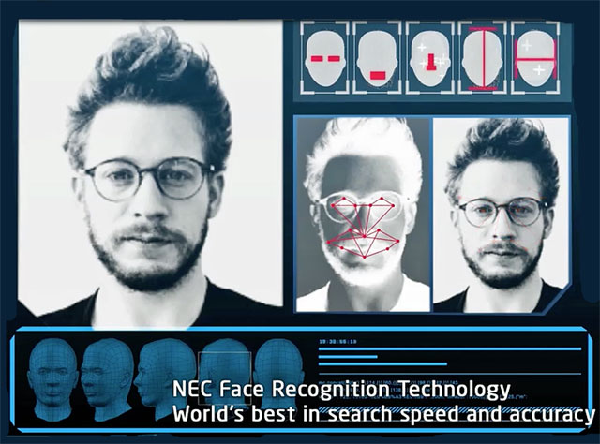

**Potential problems (Current limitation)**

There are certain drawbacks associated with facial recognition. Facial recognition can only identify people when the conditions are favourable.

Face recognition is not reliable if:

* The subject’s face is partially obscured
* The subject’s face is not facing forward
* The light is insufficient
* The facial expressions vary.

When a facial recognition system incorrectly identifies a person, that can cause a number of potential problems, depending on what kind of error it is. A system restricting access to a specific location could wrongly admit an unauthorized person – if, say, she was wearing a disguise or even just looked similar enough to someone who should be allowed in. Or it could block the entry of an authorized person by failing to correctly identify her.

In law enforcement, surveillance cameras aren’t always able to get very good images of a suspect’s face. That could mean identifying an innocent person as a suspect – or even failing to recognize that a known criminal just ran afoul of the law again.

Nevertheless, the technology is evolving quickly and there are several emerging approaches, such as [3D modeling](http://whatis.techtarget.com/definition/3D-modeling), that may overcome current problems with the systems. According to the National Institute of Standards and Technology ([NIST](http://searchsoftwarequality.techtarget.com/definition/NIST)), the incidence of false positives in facial recognition systems has been halved every two years since 1993 and, as of the end of 2011, was just .003%

Explanation to 3D modeling is in the next page.

**Privacy concerns**

http://www.bbc.co.uk/news/technology-33199275